**Project Design Phase-I**

**Solution Architecture**

|  |  |
| --- | --- |
| Team ID | PNT2022TMID21861 |
| Project Name | Smart waste management system for metropolitan cities. |
| Maximum Marks | 4 Marks |

**Solution Architecture:**

Solution architecture is a complex process.

**Solution Architecture Diagram:**

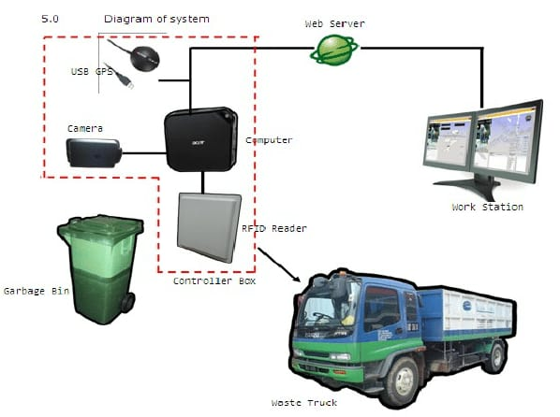

**4G/5G**